 | 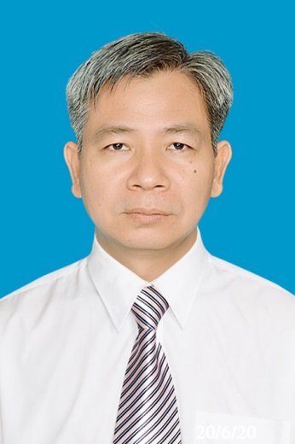 | VU QUANG HOAI  TECHNICAL DIRECTOR | CIVIL ENGINEER | STRUCTURAL DURABILITY  Ho Chi Minh City, Vietnam • +84 909 890 678 • vuquanghoai@phubac.vn  www.phubac.vn • www.tuvankiemdinh.com
EXECUTIVE PROFILE
Civil engineer and technical executive with nearly 30 years of experience in construction inspection and structural rehabilitation, focused on extending the service life of civil and marine structures. Extensive hands-on experience includes repair of corrosion-damaged reinforced concrete, shotcrete rehabilitation, FRP strengthening, waterproofing, and durability improvement. Since 2017, field experience in cathodic protection has included on-site pilot application of SACP/ICCP for reinforced concrete and, more recently, pre-contract site assessment and preliminary engineering for marine steel piles.

CORE EXPERTISE
• Service-life extension • Structural durability • Project and technical management • Reinforced-concrete corrosion repair • Cathodic protection • Structural inspection and diagnostics • Concrete repair and shotcrete • FRP strengthening • Construction supervision and site safety

PROFESSIONAL EXPERIENCE
PHUBACO COMPANY | Deputy Director | 2002 – Present | www.phubac.vn
• Lead technical activities aimed at extending structural service life through condition assessment, corrosion control, repair, strengthening, and durability improvement.
• Develop repair methodologies and technical solutions for deteriorated reinforced-concrete and marine structures.
• Conduct on-site pilot application and performance evaluation of SACP/ICCP for reinforced-concrete port structures; provide pre-contract CP engineering for marine steel piles, including site inspection, assessment of existing systems, preliminary redesign/new-system concepts, calculations, technical proposals, and budgetary estimates.
• Additional specialist experience includes wet-mix shotcrete, FRP strengthening, crack and leakage repair, concrete rehabilitation, and waterproofing.
ICCI COMPANY | Deputy Director | 2007 – Present | www.tuvankiemdinh.com
• Manage structural inspection assignments and investigate defects, deterioration, and construction-related problems.
• Prepare structural repair and strengthening proposals, and oversee project supervision and geodetic works.
CONINCO COMPANY – BRANCH OFFICE | Deputy Director | 1997 – 2007 | www.coninco.com.vn
• Delivered construction inspection, structural assessment, project supervision, and geodetic services for civil and infrastructure projects.

QUALIFICATIONS AND PROFESSIONAL DEVELOPMENT
• Professional Member (MICorr), Institute of Corrosion, United Kingdom — Membership No. 207171, 2020.
• Cathodic Protection Tester (CP1), NACE International / AMPP, United States — Certification No. 72328, 2019.
• Basic Corrosion eCourse, NACE International, 2018.
• Chief Executive Officer (CEO) Program, PACE Institute of Management, 2009.
• Civil Engineering degree, University of Technology, 1991–1996.

SELECTED PROJECT AND DESIGN EXPERIENCE
• Reinforced-concrete corrosion repair: Extensive repair experience at Phú Mỹ Port, Phú Quốc project (02/2023), PTSC Port (08/2025), SSIT Port (04/2026), Bà Rịa Serece Wharf, Vietnam–Japan Fertilizer Factory, Bến Nghé Wharf, Tiên Sa Wharf, and VIC Wharf.
• Field application of CP for reinforced concrete: Phú Mỹ Port — on-site pilot installation, testing, monitoring, and performance evaluation of SACP and ICCP systems for reinforcing steel in concrete (2017–Present).
• Pre-contract CP engineering for marine steel piles: Site inspection and assessment of existing systems, followed by preliminary SACP/ICCP redesign or new-system concepts, design calculations, technical proposals, and budgetary estimates for Vĩnh Tân, Nam Vân Phong, Cát Lái, and Hòn Chông ports.
• Shotcrete rehabilitation: Ông Thìn Bridge — concrete repair by shotcrete (06/2026).
• Structural strengthening: Đắk Tít Bridge; Ba Đông Bridge; Rạch Lò Bridge; Bãi Cháy Bridge; Ocean View Building.
• Construction inspection: Underground sewers in Districts 10 and 12; Huỳnh Tấn Phát Road; Vĩnh Long Hospital.
• Project supervision: National Highway 13; Cần Thơ Hospital; Kênh Tẻ Bridge.
• Hydropower crack and leakage repair: Sơn La; Tuyên Quang; Bình Điền; Bản Vẽ; Sông Tranh 2 hydropower plants.

TECHNICAL PRESENTATIONS
• Cathodic Protection for Civil and Marine Structures; Service-Life Extension and Durability of Civil Engineering Structures.

